Word Frequency Count Using LEX.
Aim
To write a LEX program to find the frequency of each word in a given input text.

Algorithm
- Start the program.
- Read the input text.
- Identify each word using LEX rules.
- Count the frequency of each word.
- Display each word and its frequency.
- Stop the program.

Pseudocode
BEGIN
Read input text
WHILE words are available
Identify each word
IF word already exists
Increase its frequency by 1
ELSE
Set its frequency to 1
END IF
END WHILE
Display each word and its frequency
STOP
END

Program
%{
#include <stdio.h>
#include <string.h>
char words[100][50];
int count[100];
int total = 0;
int i;
%}
%%
[A-Za-z]+ {
for (i = 0; i < total; i++) {
if (strcmp(words[i], yytext) == 0)
break;
}
if (i == total) {
strcpy(words[total], yytext);
count[total] = 1;
total++;
} else {
count[i]++;
}
}
[ \t\n]+ ;
. ;
%%
int yywrap(void)
{
return 1;
}
int main(void)
{
yylex();
printf("\nWord Frequency:\n");
for (i = 0; i < total; i++)
printf("%s : %d\n", words[i], count[i]);
return 0;
}

Input
hello world hello
welcome hello world
Output
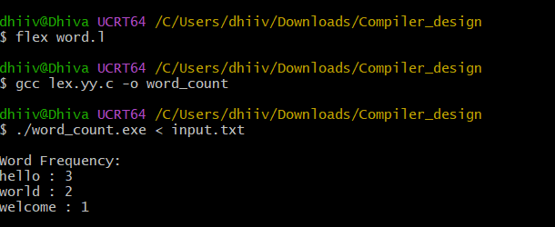

Result
Thus, the LEX program is used to find and display the frequency of each word in the given input text.

